Extra Notes

List of features within website

|  |  |  |  |
| --- | --- | --- | --- |
|  | index.html | turtles.html | involve.html |
| Small/Mobile screen | JavaScript - Full Screen Menu Bar  Responsive Image Gallery  JavaScript - Google Maps API  Back to top button | JavaScript - Full Screen Menu Bar  Responsive table  Simple image gallery  Embedded YouTube video  3D photo cube gallery (Hover or click to move)  Back to top button | JavaScript - Full Screen Menu Bar  Responsive Form  JavaScript – User name input will print name once form submitted in donation form  JavaScript – Modal Dialogue used in Adoption form once user submits form |
| Medium/Tablet screen | JavaScript - Right hand side Menu Bar  Responsive Image Gallery  Google Maps API  Back to top button | JavaScript - Right hand side Menu Bar  Responsive table  Simple image gallery  Embedded YouTube video  3D photo cube gallery (Hover or click to move)  Back to top button | JavaScript - Full Screen Menu Bar  Responsive Form  JavaScript – User name input will print name once form submitted in donation form  JavaScript – Modal Dialogue used in Adoption form once user submits form |
| Large/Desktop screen | Video background header  JavaScript - Slanted Menu Bar – Horizontal Dropdown menu  Responsive Image Gallery  Google Maps API  Turtle character animation | JavaScript - Right hand side Menu Bar  Responsive table  Simple image gallery  Embedded YouTube video  3D photo cube gallery (Hover or click to move)  Turtle character animation | JavaScript - Full Screen Menu Bar  Responsive Form  JavaScript – User name input will print name once form submitted in donation form  JavaScript – Modal Dialogue used in Adoption form once user submits form  Turtle character animation |

Errors I came across and have not solved:

- Issues with alignments on desktop screen - Different big screen sizes causes the positioning of the elements to move so it is not placed where I want it to be.

For example: on my laptop screen, the positioning of 'Our Story' text is perfectly placed within the grey background section, however, on the computer screen at the university, the bottom half of the text is covered by the Dr Seuss quote in blue background.

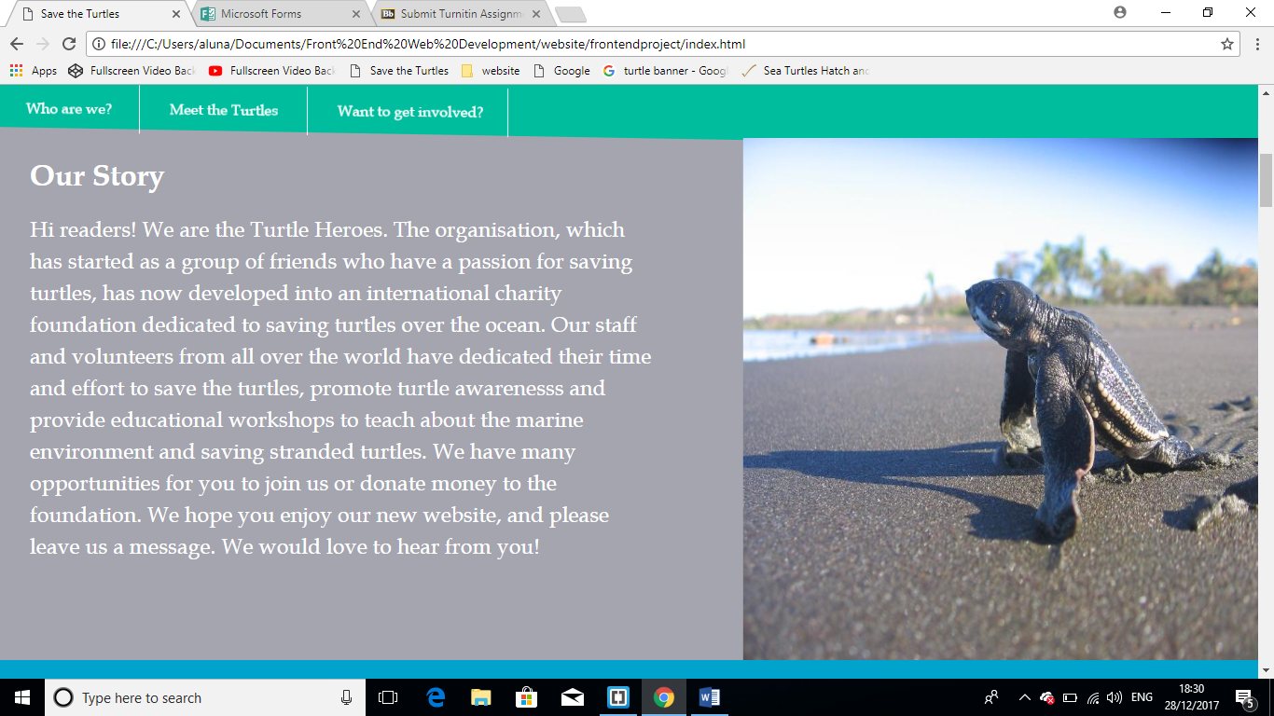

This is how it is supposed to look like (Above picture)

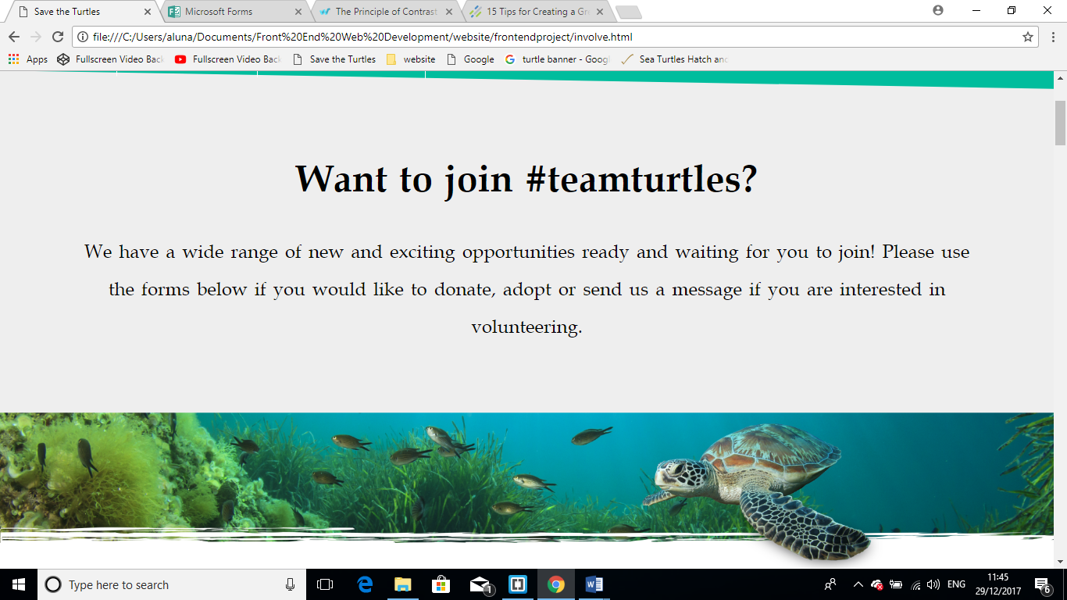With the above picture, I have noticed on some screens, the writing is covered and the turtle banner appears further away from the text showing a large amount of white space. However, this is how it looks on my laptop.

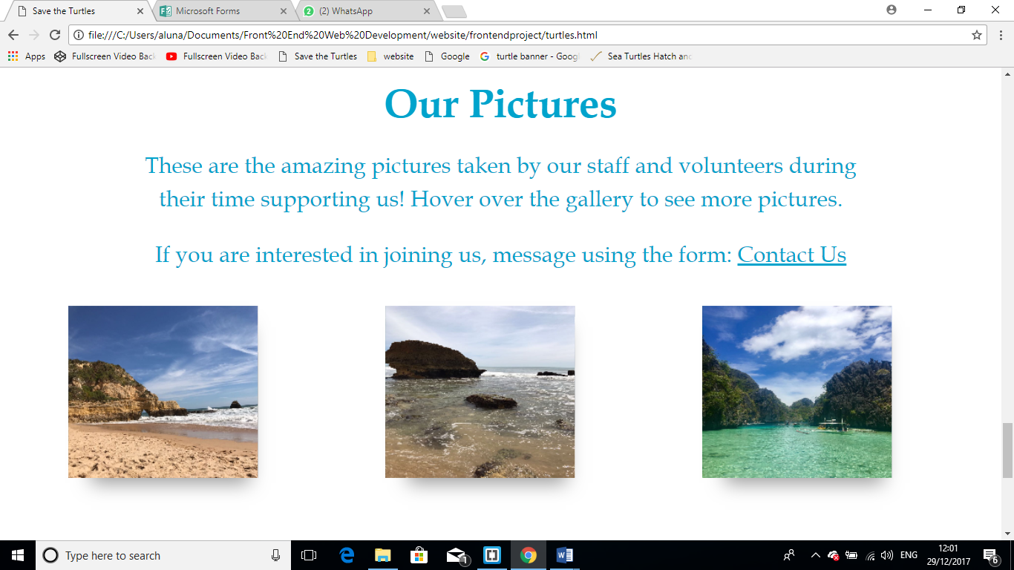

With the above pictures, I have noticed the cubes are not aligned in the centred on other screens as I designed it on my laptop (shown above).

What to improve or future considerations:

- Exploration of creative JavaScript such as hiding and showing elements

- Use of grid layout which would have been easier to group elements

- Improvements on position and alignments of contents. I struggled with aligning content to where I want it to. Avoid using margin-top and transform tags.